Birmingham Primary Schools Wellbeing Census 2025

Lay Summary

Why a Wellbeing Census?
The gap between levels of need and the availability of resources to support school-age young people with mental health and wellbeing issues has been rapidly increasing in recent years against a background where half of all mental health disorders are estimated to emerge by age 14. Wellbeing is positively associated with a range of educational outcomes and schools are an ideal environment to provide educational interventions to improve the social and emotional health of young people but need support to systematically measure and appraise the status of pupil’s mental health in their schools.

Employing wellbeing metrics to annually gauge the emotional health of young people in school settings (Thapar, Stewart-Brown, & Harold, 2021) is a practical way to indicate the current and ongoing wellbeing and future mental health status of pupils, giving schools the opportunity to both monitor and support their young people.

The 2025 Breathe Education Secondary School Wellbeing Census
Between Jan-July 2025 a “wellbeing census” was conducted in a sample of primary schools in the West Midlands. The measures employed for the survey were:

The Stirling Children’s Wellbeing Scale (Liddle & Carter, 2015). The 15-item scale SCWBS has 5 response categories across 3 scales, positive outlook, positive emotional state, and social desirability with 2 scales (positive outlook and positive emotional state) summed to provide a single score ranging between 12-60. The items are suitable for younger children and are all worded positively making the measure more suitable for use with primary schools.

The School Connectedness Scale (Resnick et al., 1997), assessed by 5-items across 5 response categories, summed to provide a single score ranging between 4-25. In 2024 we used a 4-item measure and therefore provide a 4-item comparison measure alongside this year’s new metric. Questions are adapted from Resnick et al. (1997). School connectedness is protective against a range of risk behaviours and poor academic achievement.

Simple demographics for participating pupils were collated around ethnicity, sex, school year, SEND status, free school meals and persistent absence. For inter-school comparisons we matched overall averages to publicly available school level information for %SEN support, % Pupils with English as not first language and % FSM (average last 6 years) from (Dfes, 2025) and Local Super Output Area (LSOA) deprivation data fromwww.gov.uk (2019).

This year we asked five questions around phone use as the use of phones in schools is being increasingly linked to pupil wellbeing and research in school climate. All these questions are positively worded and informed by our previous work with young people.

Note: To keep this report more accessible, we have limited the use of technical statistics. Instead, we highlight findings that represent a meaningful difference in wellbeing scores—typically around a 1–2 point change (for example, between males and females). We also indicate where results are statistically significant, meaning the difference is unlikely to be due to chance.

Measures are included in the appendix i.

Digital delivery of the census was through www.breathe-schools.co.uk, a platform that enables collaborative work to take place across a regional partnership of mental health professionals and individual schools. This is part of an ongoing programme creating resources and interventions for schools via our teacher focused website www.breathe-edu.co.uk.

For more information regarding the census and this report please contact c.palmer@warwick.ac.uk.

Who were involved?
24 primary schools in the regional area of the UK known as the West Midlands took part. Participating schools consisted of 19 academies, 3 state-maintained and 2 voluntary-aided. Birmingham LEA schools spanned across all 5 Birmingham commissioning areas including 3 schools in Area 1 (Sutton & Erdington), 1 school in Area 2 (Ladywood & Perry Barr), 2 schools in Area 3 (Hodge Hill & Yardley), 2 schools in Area 4 (Selly Oak & Hall Green) and 4 schools in Area 5 (Edgbaston & Northfield). There were an additional 11 schools from other areas (7 schools as part of Staffordshire LEA, 2 schools as part of Warwickshire LEA and 2 schools as part of Solihull LEA).

Primary Schools registered 4,133 pupils for the survey of whom 2,649 took part, providing a 64% response rate. All pupils from years 3-6 (7-10 years old) were able to take part in the survey.

Results were used to create bespoke wellbeing dashboards for each school to assist with interpretation of the data alongside this lay report.

Representation
On average, schools taking part in the Breathe Wellbeing census had a slightly higher percentage of children requiring SEN support, 16.3%, when compared to the England average of 14.2% (Dfes, 2025). The schools that took part had slightly lower proportions of pupils with first language other than English with 21.7%, compared to the England Primary School average 23.4% (Dfes, 2025). The percentage of pupils taking part in receipt of FSM was notably higher 33.7%, compared to the England average of 25.7% (Dfes, 2025). The West Midlands has slightly higher levels of these groups nationally than in the rest of the England (ONS, 2021)

Primary schools’ commissioning area and school type analysis
Table 1 shows the 2025 wellbeing census results by commissioning area and school type. Wellbeing scores were broadly consistent across areas, typically falling between 42.9 and 44.7, with the main exception of Ladywood & Perry Barr where wellbeing was notably higher at 47.9. This result should be interpreted cautiously, however, as the sample size for this area was relatively small (n=68). By school type, wellbeing was lowest in State funded schools (42.4) and highest in Voluntary aided schools (44.7).
School connectedness, measured using the 5-item scale, averaged 19.1 overall. Again, scores were similar across most areas, although Ladywood & Perry Barr stood out with a higher connectedness score of 21.5, which may also reflect the smaller sample size. Among school types, Voluntary aided schools reported slightly higher connectedness (20.3) compared with Academies (19.5), while State funded schools recorded the lowest score (18.4).
Table 1. Bham Commissioning Area & Other LEA, School Type vs Wellbeing and School Connectedness

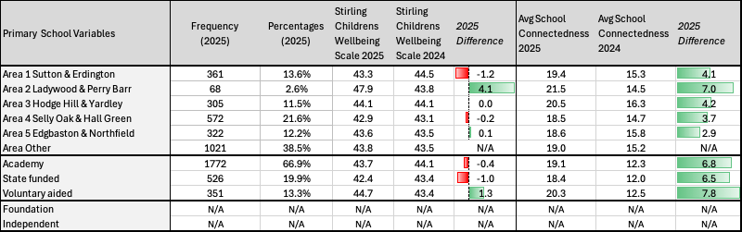

Primary school’s pupil level mental wellbeing and school connectedness
Table 2 shows the 2025 wellbeing census results for primary school pupils. The average wellbeing score was 43.7, almost unchanged from 2024 (43.8) but still below the 2021 baseline (46.6).
School connectedness, based on the 4-item scale, averaged 15.3 in 2025, a small increase from 2024 (15.2). Using the new 5-item measure introduced this year, the average connectedness score was 19.1.
Some differences were found between groups. Girls reported slightly lower wellbeing than boys, and wellbeing tended to decline from Year 3 to Year 6. Pupils with special educational needs, especially those with social, emotional and mental health needs, reported lower wellbeing than their peers. Children eligible for free school meals and persistent absentees also had lower scores. By contrast, pupils from Mixed and Black ethnic backgrounds reported slightly higher wellbeing and connectedness than average.
Overall, the findings show that while wellbeing is broadly stable over time, some groups of pupils—particularly those facing additional challenges—report lower wellbeing and connectedness than their peers.

Table 2. Demographic Grouping vs Wellbeing and School Connectedness

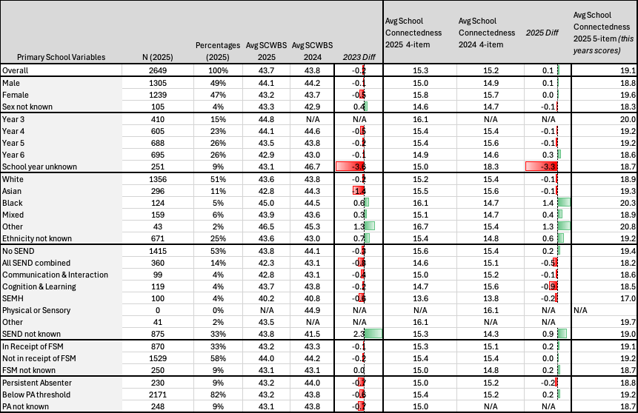

Inter-primary school analysis and local norming
Average wellbeing and school connectedness scores for individual schools are presented in Chart 1. Schools ranged between 40.7 and 48.0 for wellbeing, a meaningful difference of –7.3 in average wellbeing scores between schools. Three schools reported a meaningful difference when compared to the average wellbeing score, P7, P8 and P19.

Comparing school-level wellbeing scores with Department for Education indicators showed little evidence of systematic differences between schools. No relationship was found between average pupil wellbeing and the proportion of pupils eligible for free school meals, pupils with English as an additional language, or levels of area deprivation. A very small negative relationship was observed between wellbeing and the proportion of pupils receiving SEN support. While this finding was statistically significant, the effect was minimal and should be interpreted with caution. In practice, wellbeing scores were broadly similar across schools, regardless of these school-level characteristics.

Chart 1. Bar chart of average wellbeing and school connectedness for all participating schools with overall average line superimposed.
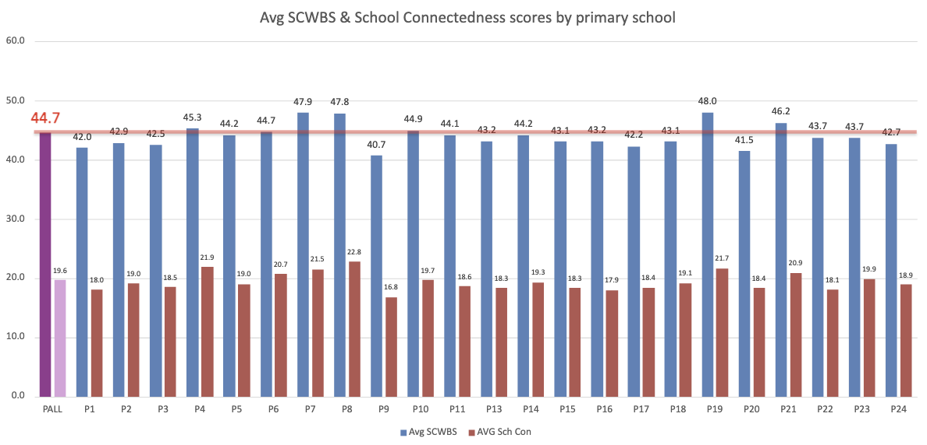

Fig 1. shows a common way to categorise this data by + or -1 standard deviation from the mean. This allows use to create norms for our data and define three categories of mental wellbeing “Low”, “Medium” and “High”. Using this method, 15% (429) pupils fell into the low category (12-35), 66% (1860) fell into the medium category (36-51) and 19% (360) fell into the high category (52-60). (Note this is a relative comparison of wellbeing categories and should not be employed for any diagnostic purposes).

Fig 1. Overall categorical percentages for all 2025 schools

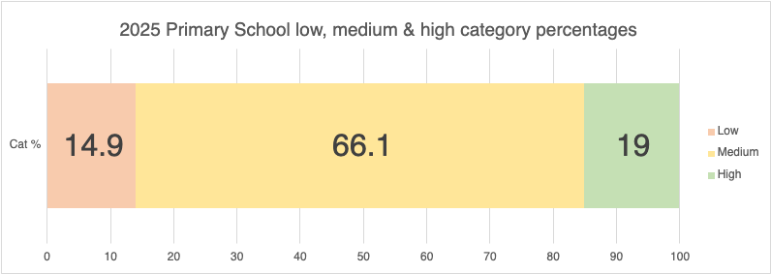

Chart 2. Bar chart displaying the % of pupils in the lower wellbeing category per school. with 20% cut-off line superimposed.
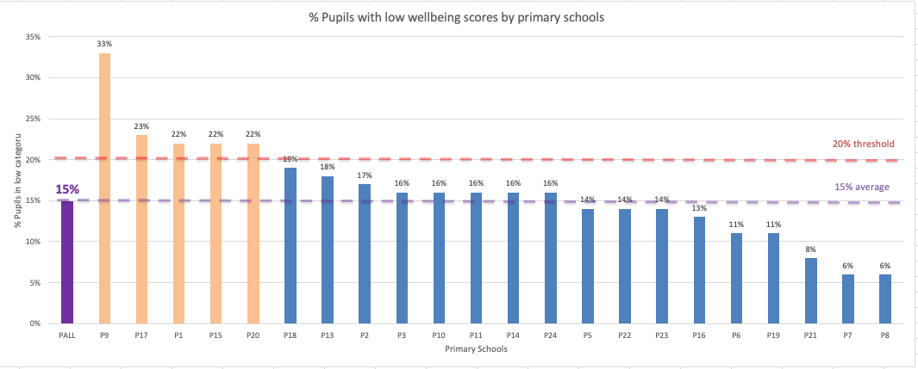

On average, primary schools reported 15% of pupils falling into the lower wellbeing category. We found that 5 schools had markedly higher (20% threshold) percentages of pupils in this lower wellbeing category and these may benefit from a review of wellbeing practices and consideration of accessing targeted support from mental health support services.

2024 and 2025 primary school comparison
10 of this year’s primary schools took part in 2024, allowing their average wellbeing scores to be compared in 2025. Chart 3 shows the average wellbeing score in primary schools that took part has increased slightly by +.09. This increase in wellbeing is shown in 5 of the schools shown in Chart 3 (P21, P4, P14, P5, P23). In schools P6 and P17, wellbeing scores remained the same.

Chart 3. Bar chart of participating school’s average wellbeing in 2024 and 2025 with 2025 overall average line superimposed

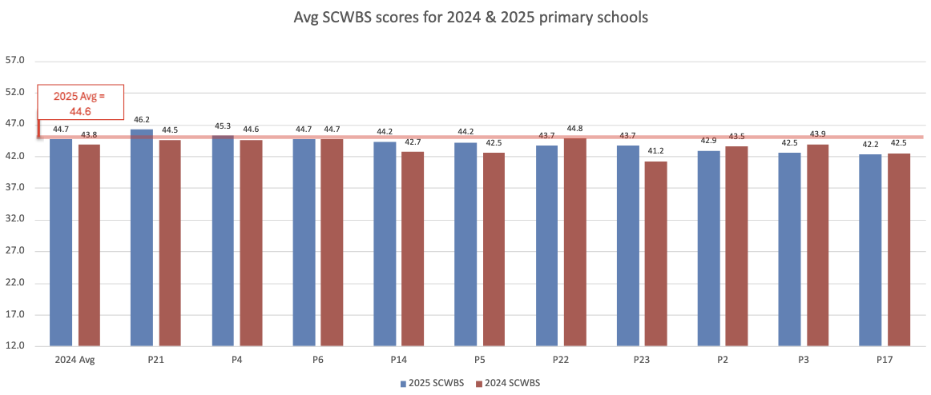

Overall findings - What this tells us
In 2025, average wellbeing for primary school pupils was 43.7, which is very similar to 2024 (43.8) and in line with the stable pattern observed over the past four years. While wellbeing remains lower than the 2021 baseline, the data suggest that overall levels are steady.

Gender
Boys continued to report slightly higher wellbeing than girls, with a gap of around 1 point on average (44.2 vs. 43.3). With such a large sample, this difference is statistically significant, but in real terms it is small and unlikely to be noticed in everyday school life. This finding is consistent with wider research showing that boys often report slightly higher wellbeing than girls.
Year group
Wellbeing scores decreased steadily across the primary years, with pupils in Year 3 reporting the highest levels (44.8) and those in Year 6 the lowest (42.5). This pattern mirrors previous surveys and highlights a gradual decline in wellbeing as pupils move through school.

SEND
Most SEND groups reported wellbeing scores close to the overall average. The main exception was pupils identified with social, emotional and mental health (SEMH) needs, who had the lowest wellbeing (40.2) and also reported the lowest levels of school connectedness. This underlines the importance of targeted support for pupils with SEMH needs to help address inequalities in wellbeing.

Socio-economic factors and ethnicity
Pupils eligible for free school meals and those with persistent absence reported lower wellbeing than their peers. In contrast, pupils from Mixed and Black ethnic backgrounds reported slightly higher wellbeing and connectedness than the overall average. These differences were modest but consistent across measures.

School connectedness
On the 4-item measure used for comparison, average school connectedness in 2025 was 15.3, a small increase from 2024 (15.2). On the new 5-item scale, average connectedness was 19.1, with pupils in Ladywood & Perry Barr and Voluntary aided schools reporting the highest scores. Across the data, pupils with higher connectedness also tended to report higher wellbeing. While the direction of this relationship cannot be confirmed, these findings support existing evidence (Waters & Cross, 2010) that school connectedness is closely linked to wellbeing. Strengthening how connected pupils feel to their school is therefore likely to be a valuable way of supporting wellbeing and may help prevent declines later in adolescence.
Phone Use

Chart 4 illustrates phone ownership by year group across all schools. About one in three pupils in Years 3 and 4 have a smartphone. This rises to almost half by Year 5, and by Year 6 around three out of four pupils own one. Very few pupils own a basic phone without internet access (“brick phone”), with figures ranging between 2% and 3.3% across year groups. These patterns mirror those reported in Ofcom’s Children and Parents: Media Use and Attitudes Report (2023), suggesting that phone ownership among children in UK has remained steady among primary school pupils over the past two years.

Chart 4: Phone Ownership by Year Group Across All Schools

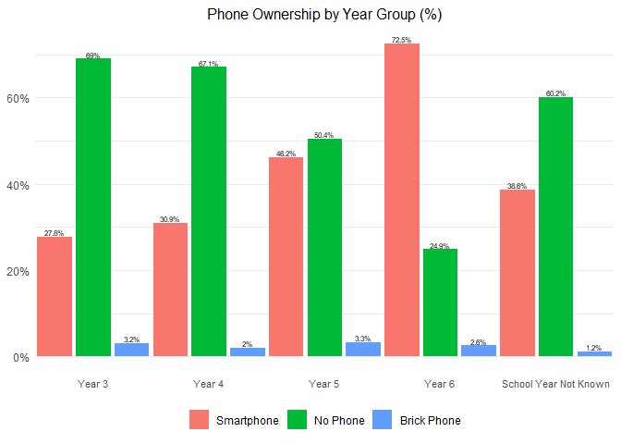

Table 3 presents SCWBS scores by phone ownership, both overall and by year group. Pupils without a phone consistently show higher wellbeing scores compared with those who own a smartphone. Overall, the difference is 0.9 points, which is small but statistically significant. When pupils are analysed by year group, the differences are smaller (0.3 points in Year 3 and 0.5 points in Years 4, 5, and 6), none of which are statistically significant. The largest difference is observed among pupils whose year group is unknown, with those without a phone scoring 2.3 points higher than those with a smartphone.

Table 3: Average Wellbeing Scores According to Phone Ownership

Year | Smartphone | No Phone | Brick Phone
Overall | 43.2 | 44.1 | 41.6
Year 3 | 44.9 | 45.0 | 39.4
Year 4 | 43.8 | 44.3 | 42.2
Year 5 | 43.4 | 43.7 | 41.6
Year 6 | 42.8 | 43.1 | 43.6
School Year Not Known | 41.8 | 44.1 | 37.0

Interestingly, pupils with a brick phone generally have lower wellbeing scores than both smartphone owners and those without a phone, except in Year 6, where they score the highest of the three groups. This effect is most pronounced in Year 3, where brick phone owners score about 5.5–5.6 points lower than the other groups. This is a meaningful difference. However, across all schools, only 13 pupils in Year 3 and 66 pupils in total had brick phones. More data would be required to see if this pattern is consistent to make any firm conclusions about this group.

The four digital literacy items range from negligible to moderate in their connection to mental wellbeing. Technical literacy shows almost no effect overall and weak effects in younger pupils (Years 3–4). This could reflect the novelty of phone ownership at this age. Connection is largely unrelated to wellbeing, except for Year 6 pupils where it becomes weakly positive. This may reflect older pupils’ growing social needs as they approach adolescence. Creative expression only links weakly to wellbeing in Year 5. Self-regulation is the most consistent and meaningful predictor, with a small-to-moderate positive relationship across all year groups.

Overall, the small but consistent difference in mental wellbeing between pupils who own a smartphone and those who do not suggests that phone ownership may have a minor impact on wellbeing. More data from future surveys will make it possible to better understand this relationship. Guidance that enables pupils to manage their phone use effectively is likely to have a meaningful positive impact on their mental wellbeing.

School Comparisons
Across four years of census data, most primary schools have reported average wellbeing at a moderate level, suggesting that for the majority of pupils wellbeing at school is a stable experience. Nonetheless, comparisons between schools show clear variation.

While all schools had average wellbeing scores above the local “low wellbeing” cut-off, the proportion of pupils falling into the “low wellbeing” group varied considerably. Five schools had over 20% of their pupils in this group, compared with the overall average of 15%. This indicates that while low wellbeing is not a diagnostic category, there are clusters of pupils within some schools who are experiencing poorer wellbeing relative to their peers, highlighting the need for targeted support in those settings.

These differences appear less related to pupil demographics, which show little association with wellbeing, and more likely reflect differences in the school environment. This is an encouraging finding, as it suggests that schools can play an active role in shaping pupils’ wellbeing. Identifying schools with higher levels of need allows for a more strategic focus on support to help create the conditions for positive change.

Summary
The 2025 wellbeing census builds on previous years and continues to highlight the importance of primary school wellbeing as a foundation for later adolescence. Using a validated and standardised approach, the census allows us to compare wellbeing across schools in a consistent way and to identify where additional support may be most needed. Findings show that while average wellbeing is broadly stable across demographic groups, there is meaningful variation between schools, underlining the influence schools can have on pupil wellbeing.

Recommendations
- Primary school wellbeing is broadly stable across demographic groups but shows variation between schools, suggesting targeted support may be most effective at the school level.
- Late primary years appear to be key transition points where preventative, curriculum-based wellbeing interventions may be especially valuable.
- School connectedness is strongly linked to wellbeing, show variation across schools and could is a useful driver for improvement if strengthened through whole-school approaches.
- Schools with higher proportions of pupils with SEND, particularly those with SEMH needs, may benefit from additional wellbeing-focused support.
- Girls report slightly lower wellbeing than boys; while the difference is small, it is consistent and should be considered when planning universal and targeted support.
- Mental wellbeing between pupils who own a smartphone and those who do not suggests that phone ownership may have a minor impact on wellbeing.

References

Dfes. (2025). Explore education statistics. Retrieved from https://explore-education-statistics.service.gov.uk
Liddle, I., & Carter, G. F. A. (2015). Emotional and psychological well-being in children: the development and validation of the Stirling Children’s Well-being Scale. Educational Psychology in Practice, 31(2), 174-185. doi:10.1080/02667363.2015.1008409
Resnick, M. D., Bearman, P. S., Blum, R. W., Bauman, K. E., Harris, K. M., Jones, J., . . . Shew, M. (1997). Protecting adolescents from harm: findings from the National Longitudinal Study on Adolescent Health. Jama, 278(10), 823-832.
Thapar, A., Stewart-Brown, S., & Harold, G. (2021). What has happened to children’s wellbeing in the UK? Lancet Psychiatry, 8(1), 5-6.
Waters, S., & Cross, D. (2010). Measuring students' connectedness to school, teachers, and family: Validation of three scales. School Psychology Quarterly, 25(3), 164.
www.gov.uk. (2019). English Indices of Deprivation 2019. UK Government Retrieved from https://www.gov.uk/government/statistics/english-indices-of-deprivation-2019

Appendix i
Primary Demographic (reported by schools)
Demographic data will be collected by school administrators/school champions from existing data available to schools.

Ethnicity (2011 Census)
Sex (2021 Census)
School Year
Percentage of Pupil Absence
SEND Type
Free School Meals

Primary School Pupils (reported by pupils)
The schedule for the Stirling Children’s Wellbeing Scale (Liddle & Carter, 2015) (SCWBS) contain the following questions and an additional 5 questions on school connectedness (each coded by 1-5 Likert scale). This was followed by five questions asking about pupil phone use. Each survey is voluntary, pupils cand digitally withdraw from the survey prior to beginning and submitting their answers.

 |  | Never | Not that much of the time | Some of the time | Quite a lot of the time | All of the time
Stirling Children’s Wellbeing Scale -
1 | I think good things will happen in my life | 1 | 2 | 3 | 4 | 5
2 | I have always told the truth | 1 | 2 | 3 | 4 | 5
3 | I’ve been able to make choices easily | 1 | 2 | 3 | 4 | 5
4 | I can find lots of fun things to do | 1 | 2 | 3 | 4 | 5
5 | I feel that I am good at some things | 1 | 2 | 3 | 4 | 5
6 | I think lots of people care about me | 1 | 2 | 3 | 4 | 5
7 | I like everyone I have met | 1 | 2 | 3 | 4 | 5
8 | I think there are many things I can be proud of | 1 | 2 | 3 | 4 | 5
9 | I’ve been feeling calm | 1 | 2 | 3 | 4 | 5
10 | I’ve been in a good mood | 1 | 2 | 3 | 4 | 5
11 | I enjoy what each new day brings | 1 | 2 | 3 | 4 | 5
12 | I’ve been getting on well with people | 1 | 2 | 3 | 4 | 5
13 | I always share my sweets | 1 | 2 | 3 | 4 | 5
14 | I’ve been cheerful about things | 1 | 2 | 3 | 4 | 5
15 | I’ve been feeling relaxed | 1 | 2 | 3 | 4 | 5

Additional questions of school connectedness (Adapted from Waters & Cross 2010)
16 | I feel proud to be a student at my school | 1 | 2 | 3 | 4 | 5
17 | I feel like I belong at my school | 1 | 2 | 3 | 4 | 5
18 | I enjoy coming to school | 1 | 2 | 3 | 4 | 5
19 | I have meaningful relationships with teachers from my school | 1 | 2 | 3 | 4 | 5
20 | I feel like I can be myself at school | 1 | 2 | 3 | 4 | 5

Phone Use – Jacki add references
21 | What kind of phone do you have? | I have a smartphone | I have a brick phone (no internet phone) | I don’t have a phone
22 | I am confident I know how to use all the things my phone can do, such as making calls, sending messages, changing phone and app settings, and downloading and using apps. | Very strongly disagree | Disagree | Neutral | Agree | Very strongly agree
23 | I use my phone to feel more connected to my friends.
24 | I use my phone to make things like videos, photos, drawings or stories to show how I feel or what I like.
25 | It’s easy for me to take a break from my phone for a while.

Stirling Children’s Wellbeing Scale (SCWBS)(Liddle & Carter, 2015).
The SCWBS is 15-item holistic, positively worded scaled used to measure emotional and psychological wellbeing in younger children aged 8 -15 years. It is a standardised tested measure that has been specifically made by educational psychologists. The scale covers areas of wellbeing such as: optimism, cheerfulness and relaxation, satisfying interpersonal relationships, clear thinking and competence. The questions are scored with a five-point response scale 1 to 5 and contains three sub-scales: Positive Outlook, Positive Emotional State and Social Desirability. A comprehensive report of the measure can be found here: https://warwick.ac.uk/fac/sci/med/research/platform/wemwbs/using/faq/scwbs_children_report.pdf

School Connectedness – Waters & Cross (2010)
School Connectedness question are adapted from Waters and Cross (2010) (each coded by 1-5 Likert scale).

Phone Use – (Jacki add references?)
This year we are asking five questions around phone use as the use of phones in schools is being increasingly linked to pupil wellbeing and research in school climate. All these questions are positively worded and informed by our previous work with young people.

