Emotional Zone scenario worksheet

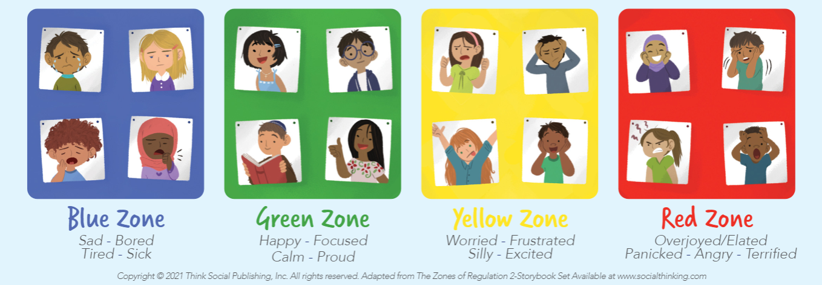

Mariah has caught a cold and has to stay home from school. She has been at home for two days and feels sad as she is missing out on playing with her friends at school. She has to stay in bed so that she can recover but she is bored which is making her sadder.
What zone is Mariah in? What could help her move into the green zone?

Amber is walking home after school and she sees a big dog barking at another dog. Amber starts to panic and she freezes on the street and doesn’t want to move.
What zone is Amber in? What could help her move into the green zone?

Michael plays football and this weekend scored the winning goal for his team. He is feeling very happy and proud of what he did and is feeling focused and ready for the next week.
What zone is Michael in? What could help him move into the green zone?

Shanice and Mohammed are drawing in class. Shanice is getting worried because she hasn’t finished her drawing yet and it is nearly home time. She tries to rush to finish it but ends up tearing the paper which makes her very frustrated. Mohammed on the other hand is having fun drawing and is excited about all the different colors he gets to use.
What zone Shanice in? What could help her move into the green zone?

What zone Mohammed in? What could help him move into the green zone?

