Emotional Zone scenario teacher key

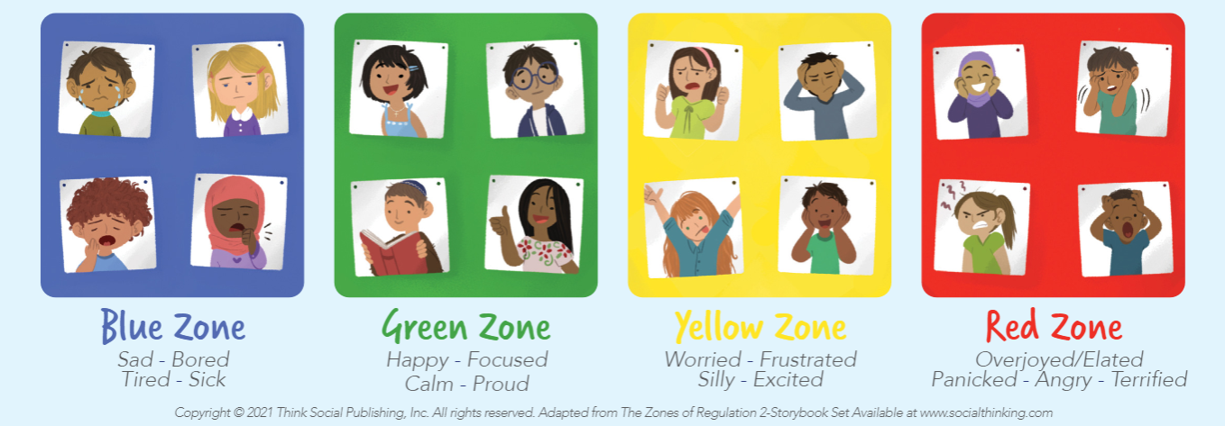

Mariah is in the BLUE zone.

Potential answers: playing games with her online, writing her a get well soon card, visiting her and taking her soup

Amber is in the RED zone (she is PANICKING)

Potential answers: cross the street, take a deep breath and understand that she is safe, wait for the dogs to stop barking and continue walking
Michael is in the GREEN zone – at different points within the scenario he could have been in the other zones (excitement, terrified) but the scenario reflects proud and focused.

No potential answers, but could have a discussion about feeling things from all the zones or moving back and forth within one activity.

Shanice and Mohammed are both in the YELLOW zone.

Potential answers: Mohammed could help Shanice finish her drawing, they could work together on the drawings to move into a calmer feeling, they could talk about how their feeling

