Perzines
Perzines are a genre of zines; the "per" meaning "personal".
A perzine usually:
- Includes the work of one person
- are written about one's own personal experiences, Opinions and observations
- Can include drawings, writing, collage, photographs, comics or any other art form!
See below some examples of what could be included in a perzine about self-esteem…
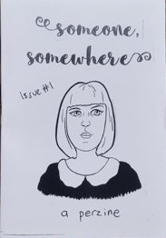
_____________________

What am I good at?
Lots of things! More than
Lots to celebrate!
_____________________



