Birmingham Secondary Schools Wellbeing Census 2025

Lay Summary

Why a Wellbeing Census?
The gap between levels of need and the availability of resources to support school-age young people with mental health and wellbeing issues has been rapidly increasing in recent years against a background where half of all mental health disorders are estimated to emerge by age 14. Wellbeing is positively associated with a range of educational outcomes and schools are an ideal environment to provide educational interventions to improve the social and emotional health of young people but need support to systematically measure and appraise the status of pupil mental health in their schools.
Employing wellbeing metrics to annually gauge the emotional health of young people in school settings (Thapar et al., 2021) is a practical way to indicate the current and ongoing wellbeing and future mental health status of pupils, giving schools the opportunity to both monitor and support their young people.
Through extending the wellbeing census to investigate factors that may protect wellbeing, this provides schools with targeted areas to both monitor and support their young people. We can also use this data to evaluate current and future interventions that support young people in the city and try find out what works and is useful regarding their wellbeing. In 2024, we completed an extended wellbeing census to pilot the feasibility of collecting both wellbeing and protective factor data in schools. This survey was first completed with schools who volunteered to take part in the extended census. Following its success, in 2025 all secondary schools took part in the extended wellbeing census to measure factors that can protect wellbeing. To make the survey easier for pupils to complete, we applied statistical techniques to reduce the number of questions while keeping the measures robust. This makes 2025 a transition year to these new scales.

The 2025 Breathe Education Secondary School Wellbeing Census
Between Jan-July 2025 a “wellbeing census” was conducted in a sample of secondary schools across the Birmingham LEA. The measures used for the survey were:
In previous years of the wellbeing census the 14-item Warwick-Edinburgh Mental Wellbeing Scales (WEMWBS (Tennant et al., 2007) has been used. In 2025 this has been adjusted to the shorter 7-item version called the Short Warwick-Edinburgh Mental Wellbeing Scale (SWEMWBS (Stewart-Brown et al, 2009)). The scale has 5 response categories, summed to provide a single score ranging between 7-35. All items are suitable for young people and worded positively, covering both emotional and functional aspects of mental wellbeing thereby making the concept more accessible.
The School Connectedness Scale (Resnick et al., 1997) which is assessed by 5 items across 5 response categories, summed to provide a single score ranging between 5-25. Questions are adapted from Resnick et al. (1997). School connectedness is protective against a range of risk behaviours and poor academic achievement.
Demographics for pupils were collected around ethnicity, sex, school year, SEND status, free school meals and persistent absence. For inter-school comparisons we matched overall averages to publicly available school-level information, %SEN support, % Pupils with English as not first language and % Free School Meal (FSM) status (average of last 6 years) from Dfes (2021) and Local Super Output Area (LSOA) deprivation data from www.gov.uk (2019).
4 items from the Multidimensional Scale of Perceived Social Support were used to identify an individual’s perceived level of social support from friends and family (Zimet et al., 1988). Each subscale is summed to provide a single score ranging between 2-10, with a higher score representing higher perceived support.
2 items were used from the Self-Kindness subscale from the Self-Compassion Scale Youth (Neff et al, 2021) to assess self-kindness and provide an insight into self-compassion This scale is summed to provide a single score between 2-10, with a higher score representing more self-kindness.
The cognitive reappraisal subscale was used from the Emotion Regulation Questionnaire Short Form (Preece et al., 2023). This is summed to provide a single score between 3-15, with a higher score representing higher use of this regulation style.
One question taken from the Pittsburgh Sleep Quality Index was selected to provide an insight into overall sleep quality over the last month (Buysse et al., 1989). This question provides a score between 1-4, with a higher school representing better sleep quality.
To get an insight into diet, three questions asking what you ate for breakfast today, what did you eat for lunch yesterday, and how many portions of fruit and vegetables did you eat yesterday, were adapted from Hayhoe et al (2021).
This year we are asking five questions around phone use as the use of phones in schools is being increasingly linked to pupil wellbeing and research in school climate. All these questions are positively worded, informed by our previous work with young people and adapted from digital literacy scales that have been tested on young children (Global Kids Online, 2019; Helsper et al., 2020; Rosič et al., 2022). One item asks what kind of phone the pupil has (smartphone, phone without internet access, or no phone). The other 4 items highlight key areas of digital literacy identified by researchers:
- Technical Skills: knowing how to use a phone effectively
- Communication: using a phone to feel more connected with others
- Content creation: using a phone as a tool for self-expression (e.g. photos, videos)
- Self-Regulation: managing phone use (e.g. limiting excessive use)

Research suggests these skills can help keep young people safe from online harms while also supporting self-expression and social connection.
Following the 2025 update to measurement scales, 2024 data has been re-scaled to ensure comparability with last year.
Measures are included in appendix i.
Digital delivery of the census was through www.breathe-schools.co.uk, a platform that enables collaborative work to take place across a regional partnership of mental health professionals and individual schools. This is part of an ongoing programme creating resources and interventions for schools via our teacher focused website www.breathe-edu.co.uk.
For more information regarding the census and this report please contact c.palmer@warwick.ac.uk.

Who were involved?
28 secondary schools collected data for 12,901 pupils between the ages of 11-18 years. Participating schools constituted of 20 academies, 1 foundation school, 2 independent schools, 2 state-funded school, 1 voluntary aided school, 1 free school and 1 pupil referral unit. Birmingham LEA schools spanned across all 5 Birmingham commissioning areas including 6 schools in Area 1 (Sutton & Erdington), 4 school in Area 2 (Ladywood & Perry Barr), 2 schools in Area 3 (Hodge Hill & Yardley), 7 schools in area 4 (Sutton & Erdington) and 6 schools in Area 5 (Edgbaston & Northfield). There were an additional 3 schools from other areas (1 school part of Staffordshire LEA, 1 school part of Warwickshire LEA and 1 school part of Coventry LEA).
Secondary Schools registered 24,718 pupils for the study of which 12,901 took part a 52% response rate. All pupils from years 7-13 (11-18 years old) were able to take part in the census.

Representation
Census schools were generally representative of the broader picture of schools in Birmingham LEAs. The schools that took part in the survey had a slightly lower percentage of pupils with special educational needs support 13.6%, when compared to the England average of 14.2% (Dfes, 2022). The schools that took part had higher proportions of pupils with their first language other than English with 26.2%, compared to the England average 21.4% (Dfes, 2022). The percentage of pupils taking part in receipt of FSM was 35.3%, slightly higher when compared to the England average of 25.7% (Dfes, 2022). The West Midlands typically reports higher levels of these indices compared to the rest of the England. An over-representation of pupils from an Asian background (33%) was apparent from the sample in comparison to the actual population of the West Midlands by age group (ONS, 2021).
A note on terminology used in this analysis.
Significant denotes statistical significance – Statistical significance means that our findings are unlikely to have occurred by change, but this does not always indicate a large difference between groups.
Meaningful’ here is based on the SWEMWBS threshold: a 1-point difference is considered meaningful at the individual level (Shah et al., 2018). Although this pertains to individual change, in cohort analysis even ~0.5–1 point shifts in average scores can reflect real population-level effects. For example, if one group of pupils scores around 0.5–1 point higher on average than another, we treat this as a meaningful difference. Both groups may still have generally good wellbeing, but the higher-scoring group is likely experiencing a real advantage, which could matter for how support is planned
It is also important to note that some differences may not be statistically significant, especially where sub-samples are small. For this reason, we highlight findings that are both statistically significant and meaningful as the most important in our data.
Commissioning Area and School Type Mental Wellbeing and School Connectedness
Table 1. details the wellbeing census result categorised by commissioning area of school and school type. Assessing wellbeing by commissioning area revealed that average wellbeing was reported to be the highest in the Area 2 (Ladywood & Perry Barr) 22.4, which was statistically higher than all other areas except for Area 3 (Hodge Hill & Yardley). The Other LEA area was statistically lower than Areas 1, 2 and 3. Wellbeing was found to be the highest in voluntary aided schools compared to all other school types. Most commissioning areas and school types have shown improvements in wellbeing and school connectedness scores from 2024.
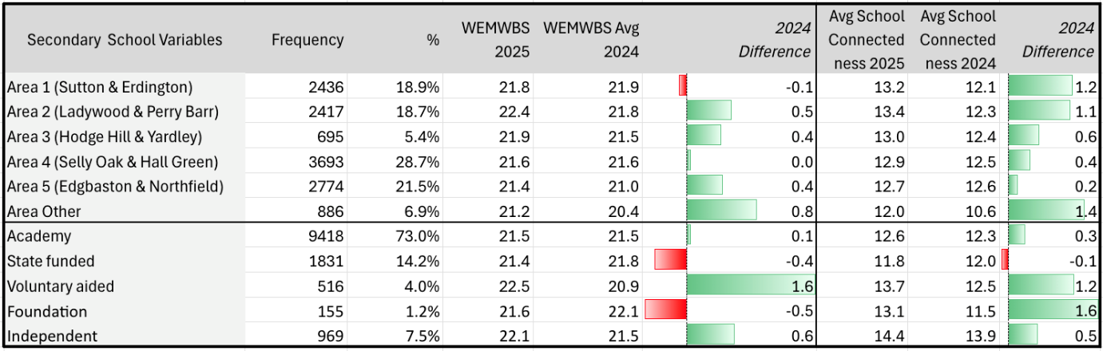
Table 1. Commissioning Area and School Type Wellbeing & School Connectedness

2025 Secondary School Wellbeing
Table 2. details 2025 wellbeing scores for secondary schools. Overall average wellbeing score for secondary school pupils in our sample was 21.7 - similar to 2024 (21.9) data. It is still somewhat lower than the UK population average found for 11–16-year-olds in 2020 (24.6) (NHS Digital, 2020). Our findings suggest that average wellbeing appears relatively stable across years but variable between schools.
Females reported lower mental wellbeing (21.3) in comparison to males (22.4) - a small but significant difference of between groups. Although the average gender difference in wellbeing across secondary school is small, this headline conceals important developmental dynamics. Whilst males and females report similar wellbeing in primary school, the transition to secondary marks a divergence: females’ wellbeing declines more steeply than males’, producing the largest gender gaps in mid-secondary years. In essence males appear to stabilise by Year 8–9, whereas females continue to decline, suggesting that puberty, peer dynamics, and social pressures may underpin this critical period of divergence.

Pupils reporting from an Asian and Black ethnic group had the highest average wellbeing (Asian 22.0, Black 22.0) compared to all other simplified ethnicities. Whilst this was a statistically significant finding (actual differences in scores) the differences in scores were small. Pupils with SEND reported slightly lower wellbeing score than those without SEND, a small but significant difference of -.9. Pupils in receipt of free school meals reported slightly lower wellbeing score than those not in receipt, a small but significant difference of -.5. Pupils reported as persistent absenters also reported slightly lower wellbeing on average than non-absenters, again a small but significant difference of .7.
A very weak trend was found between secondary pupil wellbeing and school year (i.e. pupil age) with wellbeing slightly decreasing as school year (pupil age) increased, but this finding was not significant.

2025 Secondary School Connectedness
Table 2. details 2025 school connectedness for secondary schools. Overall average school connectedness for secondary school pupils was calculated as 13.0, a slight increase on the overall average score in 2024 (12.3). School connectedness was slightly higher for nearly all demographic groups compared to 2024, except for those categorised as SEMH SEND type. A strong positive relationship was found again between 2024 secondary school pupil wellbeing and school connectedness with higher wellbeing related to higher school connectedness. As we have observed our previous census school connectedness is much lower on average at secondary schools in comparison to primary schools where we observed an average school connectedness score of 19.1.
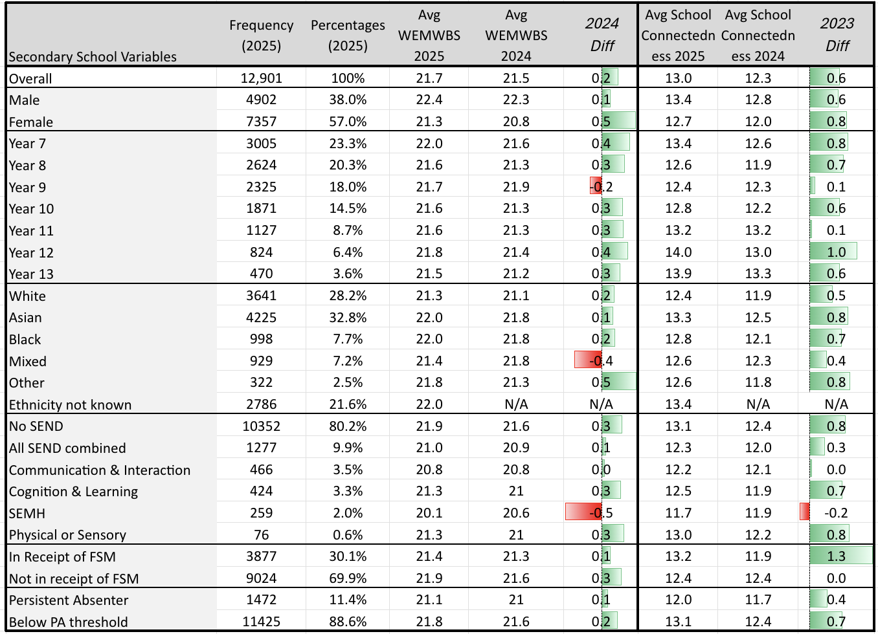
Table 2. 2025 Wellbeing and School Connectedness with 2024 differences

Inter-secondary school analysis and local norming
Average wellbeing and school connectedness scores for individual schools are presented in Chart 1 - ranging between 20.2 and 23.6, showing a -3.4 overall statistically significant and meaningful difference in wellbeing between schools. Wellbeing and school connectedness were strongly associated at school level (schools with higher wellbeing tended to have higher school connectedness). Comparing Department for Education school-level data we found weak but significant associations between schools reporting higher percentages of pupils on free school meals over the last 6 years, and % of SEND pupils to have lower levels of average school wellbeing. No other significant school level associations for wellbeing were found for % of pupils where English is not first language or index of multiple deprivation decile. Negative weak but significant associations were found between school connectedness and all these factors; % SEND, % English not first language, % FSM in last 6 years, or index of multiple deprivation.

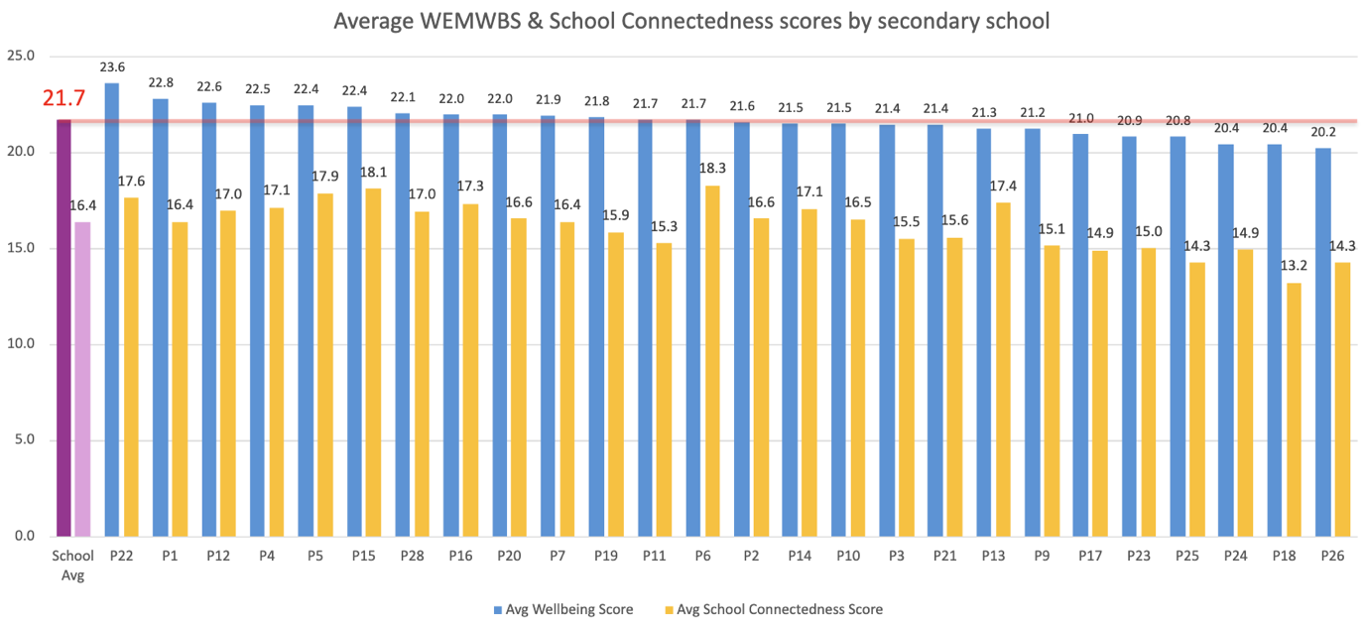
Chart 1. Bar chart of average wellbeing and school connectedness for all participating schools with overall average line superimposed
Fig 1 displays a common way to categorise data by + or -1 standard deviation from the overall mean (average) score. This enables us to create ‘norms’ from our data and define three categories of mental wellbeing “Low”, “Medium” and “High”. Using this method, 13.7% (1,575) pupils fell into the low wellbeing category, (7-17), 72.7% (9,512) the medium wellbeing category (18-26) and 14.1% (1,814 the high wellbeing category (27-35). (Note this is a relative comparison of wellbeing categories and should not be employed for any diagnostic purposes).
Fig 1. Overall categorical percentages for all 2025 schools

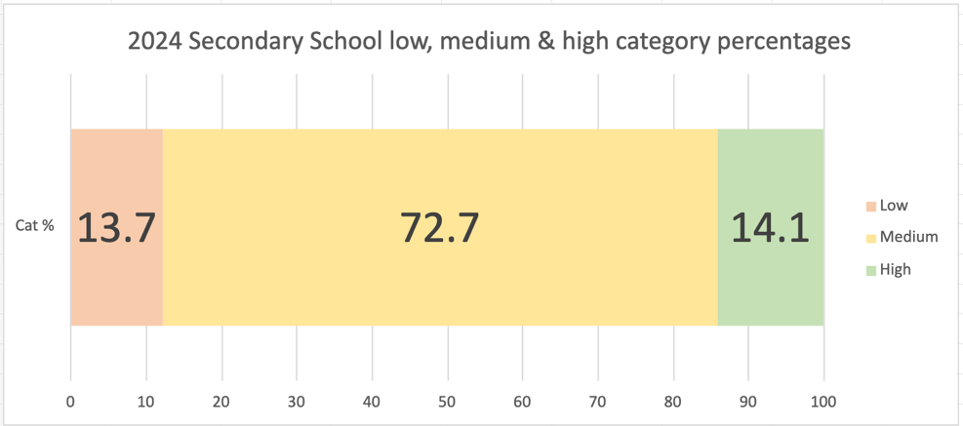

Chart 2. Bar chart displaying the % of pupils in the lower wellbeing category per participating school in 2025 with 20% cut-off line superimposed.
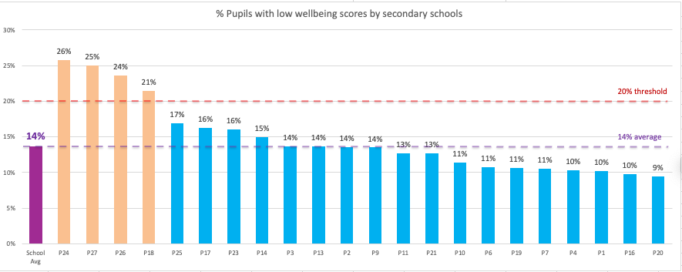
On average secondary schools had 14% of pupils falling within the lower wellbeing category. We found that 8 schools in our sample reported a higher % of pupils falling within the lower wellbeing category and 4 schools reported markedly higher (>6% more than average) percentages of pupils in this lower wellbeing category. Schools with more pupils in the lower wellbeing category may benefit from a review of wellbeing practices and consideration of accessing targeted support from mental health support services.

2024 and 2025 school comparison
20 of this year’s participating secondary schools also took part in the 2024 census and wellbeing scores could therefore be compared with 2025 scores. Chart 3 shows that for these schools, most had improved average wellbeing compared to last year.
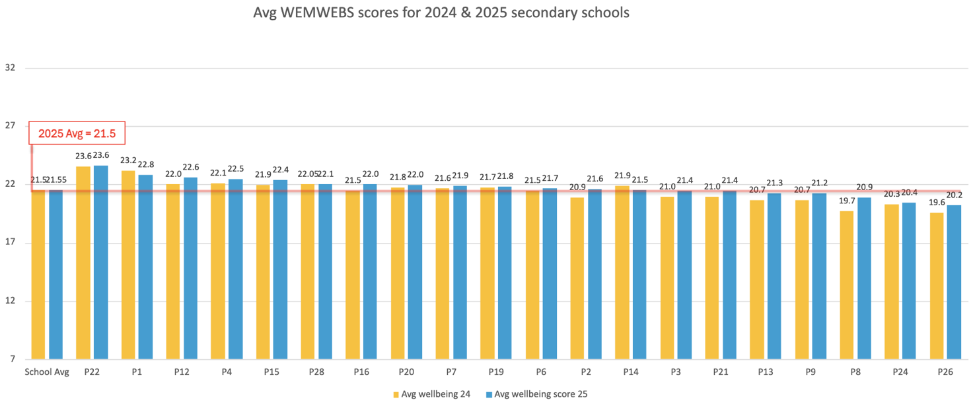
Chart 3. Bar chart of participating school’s average wellbeing in 2024 and 2025 with 2025 overall average line superimposed

What this tells us
Gender
Male students in this sample reported slightly higher wellbeing than female students. The gap (~1.15 points) is small in size but large enough to be both statistically significant and meaningful, especially at the population level given the large sample. This finding is replicated in our 2022, 2023 and 2024 data but also other recent measurements collected during Covid-19 for 13–16-year-olds (Widnall et al., 2020) and supports previous international evidence around the gender gap in adolescent health (Campbell et al., 2021). This year is the first year we have also seen a significant difference between male and females in our primary school data.
Ethnicity
On average, pupils from White backgrounds reported slightly lower wellbeing than pupils from Asian and Black backgrounds – about half to three-quarters of a point lower on the wellbeing scale. While this is only a small gap, it has shown up consistently in our 2022 and 2023 results, though not in the primary school data. National NHS figures show a similar pattern (Newlove-Delgado et al., 2021), with White children reporting more mental health difficulties than some other groups. These findings should be treated with care, as they are based on broad ethnic categories and may also reflect the make-up of our local sample.
Age
Overall, when looking across all secondary year groups (Years 7–14), there was no significant relationship between age and wellbeing. However, when focusing only on Years 7–10, we did find a very weak negative relationship, with wellbeing appearing to dip slightly in older year groups. This effect is extremely small in size, and together with findings from 2023 and 2024 suggests that age has only a minimal influence on wellbeing in secondary schools, or that more detailed analysis may be needed to detect any nuanced effects.
School Connectedness
School connectedness has shown a slight overall increase compared to last year, and we continue to find a strong positive relationship between connectedness and wellbeing. While the causal direction of this relationship cannot be determined from our data, repeated surveys consistently highlight school connectedness as a key correlate of wellbeing (Waters & Cross, 2010). A consistent finding across four years of our data is a moderate drop in connectedness when pupils move from primary to secondary school. This echoes earlier work (Lester et al., 2013), which found that pupils report lower connectedness during this transition, likely reflecting the less cohesive nature of secondary schools (with less familiar teachers and peers). Importantly, Lester et al. also linked this reduced connectedness to higher levels of depression and anxiety. Taken together, the evidence points to school connectedness as a critical factor in supporting pupil wellbeing.
Phone Use
Chart 4 shows phone ownership by year group across all schools. A large majority of pupils own a smartphone in every year group. The rate of ownership is at 74.1% in Year 7 and increases year on year to 95.3% in Year 13. However, these figures are lower than those reported in the Ofcom Children and Parents: Media Use and Attitudes Report (2023), which found that 98% of young people in the UK aged 12–15 own a mobile phone. This suggests that phone ownership among secondary school pupils may be declining, although more data would be needed to confirm this trend.
Chart 4: Phone Ownership by Year Group Across All Schools
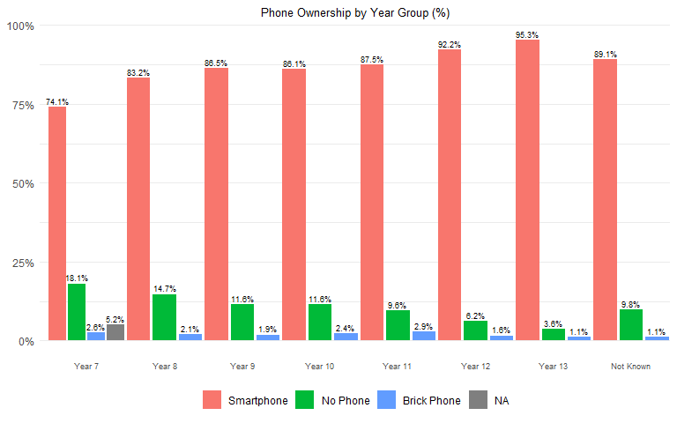

Table 3 presents SWEMWBS scores by phone ownership, both overall and by year group. Overall smartphone users’ scores are on average 0.1 point higher than those with no phone. When we look by year group, the results are more mixed.
Table 3: Average Wellbeing Scores According to Phone Ownership
Year | Smartphone | No Phone | Brick Phone | NA
Overall | 23.8 | 23.7 | 23.1 | 23.6
Year 7 | 24.0 | 24.4 | 24.2 | 23.6
Year 8 | 23.6 | 23.6 | 22.0
Year 9 | 23.7 | 23.6 | 23.3
Year 10 | 23.6 | 23.4 | 22.1
Year 11 | 23.7 | 22.2 | 23.2
Year 12 | 23.8 | 23.7 | 22.0
Year 13 | 23.3 | 24.6 | 23.0
School Year Not Known | 23.9 | 23.8 | 24.9

In Year 7, pupils without a phone have slightly higher wellbeing, scoring 0.4 points above smartphone users. By Year 8, smartphone users and non-phone users have identical scores. In Years 9 and 10 smartphone users report slightly higher average wellbeing than non-phone users, 0.1 and 0.3 points respectively. In Year 11, those with smartphones score 1.5 points higher than non-phone users, a significant and meaningful difference. In Year 12, the gap shrinks again to just 0.1 points. But in Year 13, the pattern is reversed: pupils without phones score 1.3 points higher than smartphone users, a significant and meaningful difference.
Overall, pupils who own a phone without internet access (a “brick phone”) score 0.7 points lower than smartphone users and 0.6 points lower than pupils without phones. When looking at each year group separately, they generally have lower wellbeing than the other two groups. However, these pupils make up less than 3% of each year group, so more data would be needed to determine whether this pattern is consistent before drawing firm conclusions about this group.
The four digital literacy skills show small to near moderate positive links with mental wellbeing. Technical literacy is weakly related to mental wellbeing across all year groups, except Year 13, where the link is negligible. Connection is weakly related in across all year groups. Creative expression shows a weak connection only in Years 11 and 13. Self-regulation has the strongest connection with mental wellbeing, showing a small-to-moderate positive relationship in all year groups, except Year 13 where it has only a weak link.
In general, these results suggest that phone ownership’s effect on mental wellbeing may differ by age, however more data from future surveys is needed to confirm these patterns. Focusing guidance on supporting pupils in managing their phone use effectively may have a positive impact on their mental wellbeing.

Comparisons across Schools
On average, 14% of pupils scored in the low wellbeing category (<18 on SWEMWBS). Four schools had more than 20% of pupils in this category, above the threshold we consider as an alert for further strategic attention. Most schools fell below this threshold, with several reporting 10% or fewer pupils in the low wellbeing group. These differences highlight where additional support may be needed, while also showing examples of schools with stronger wellbeing outcomes that may provide learning for others.
Schools with higher numbers of pupils receiving free school meals or with a greater proportion of pupils with special educational needs tended to report slightly lower average wellbeing. In contrast, we did not find any clear link between average wellbeing and either the proportion of pupils with English as an additional language or the overall deprivation level of the school’s local area.
We found that most of the schools (20 schools) which had also taken part in 2024 reported slight improvements in average wellbeing for 2025. Alongside this however, it appeared there was relative consistency in wellbeing reporting within schools from the previous year which suggests these modest improvements may be less a feature of individual pupil demographics and more related to general improvements to the environmental and contextual elements of pupils’ lives. It is our opinion that this should be regarded as suggesting that schools can shape and influence wellbeing positively and that a wellbeing census can also help to identify schools in most need of support to help create these positive changes.

Factors that protect wellbeing
Table 4 details the 2025 extended census which collected data on wellbeing as well as factors that may protect wellbeing. These factors included school connectedness, family support, peer support, emotion regulation using cognitive reappraisal, self-kindness, sleep quality and fruit/vegetable consumption. Overall scores for each factor can be seen in Table 3.

The scores for all protective factors seem to slightly decrease from year 7 to year 10, and then slightly increase again from year 10 to year 13. The Asian ethnic group generally shows the highest score, or joint highest score when compared to other ethnic groups for each protective factor. Those with SEND have similar but slightly lower scores in protective factors than those without SEND, but this is particularly lower in self-regulation scores. Out of all the SEND categories, those with SEMH had the lowest scores for all protective factors. Pupils receiving FSM had slightly lower scores than those who do not receive FSM for most of the protective factors. Pupils who were persistently absent from school also showed lower scores for the protective factors when compared to those who are not persistently absent from school.

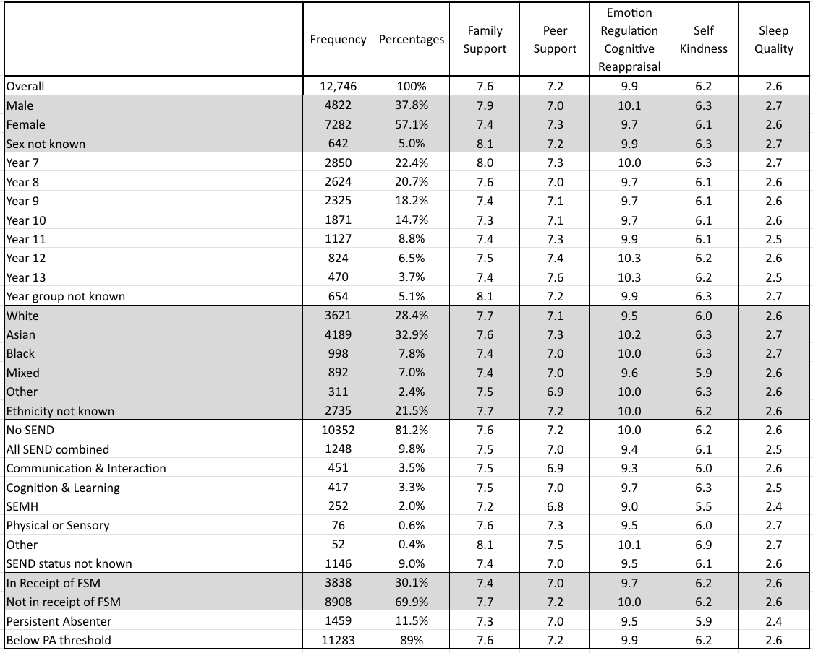
Table 4. 2025 Factors That Protect Wellbeing Average Scores

Food Choices
Chart 5. Percentages of Pupils for Breakfast and Lunch Food Choices, and Fruit/Vegetable Consumption for All Schools that Took Part.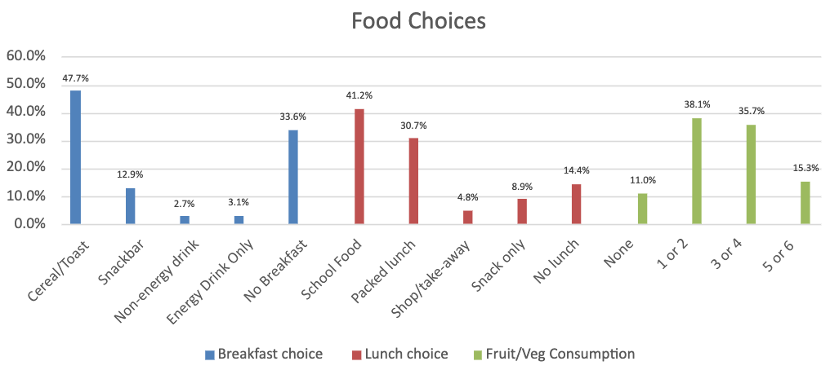

Chart 5 provides a breakdown of the food choices that are generally made by pupils on a school day. As diet can have an impact on physical health and overall wellbeing it is important to look at pupil food choice as this can impact mood, concentration, and energy levels in school.
Relationship between protective factors and wellbeing
Table 5 below shows the correlational relationships between wellbeing and each protective factor. Self-kindness was found to have the strongest relationship with wellbeing scores and therefore would be considered the most influential factor for protecting wellbeing. Similarly, school connectedness also demonstrated a strong influential relationship with wellbeing scores.

This was closely followed by cognitive reappraisal and family support also having a medium connection and influence on wellbeing scores. Peer support and sleep quality showed a medium connection and influence on wellbeing scores, but these were less influential than the factors discussed above. Fruit/vegetable consumption showed a weak connection to wellbeing scores.

Table 5. Correlational Relationships Between Wellbeing and Protective Factors for All Schools That Took Part.
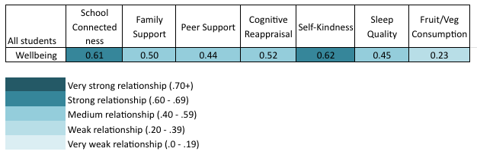

Summary
The 2025 wellbeing census has again built on findings from previous years highlighting a disparity in wellbeing between boys and girls at secondary school, and now potentially emerging in primary school. This is alongside some potential emerging differences for ethnicity, and age when considering comparisons to school connectedness between primary and secondary schools. We continue to be able to evaluate pupils and schools’ wellbeing in a validated and standardised way that has good potential to inform strategic decision-making and help direct resources to schools in most need of support.
This year we have extended the wellbeing census to look at factors that can protect wellbeing. This has allowed us to build on our understanding of the drivers of wellbeing in Birmingham and provides information to direct local mental health support teams and individual schools for targeted support to improve wellbeing.

Recommendations
- Girls’ wellbeing at secondary school is a concern and should be an area of targeted focus for all schools.
- Although the overall gender difference in wellbeing across secondary school is small, this masks important developmental variation: boys report higher wellbeing in the early secondary years, but by mid-secondary the pattern reverses, with girls showing lower wellbeing and the gap widening through adolescence.
- Early secondary school years are a key transitional time for considering the application of preventative educational wellbeing interventions integrated with school’s curricula.
- Schools with higher percentages of FSM and SEN % pupil populations may benefit from increased support for wellbeing.
- Schools differ in wellbeing and school connectedness and would benefit from tailored approaches to its unique wellbeing profile and needs.
- Self-kindness and school connectedness show the strongest connections to wellbeing and should be considered for school interventions.
- Schools should support pupils to develop self-regulation skills in their phone use, as this shows the strongest and most consistent positive link with wellbeing across year groups.

References
Campbell, O. L., Bann, D., & Patalay, P. (2021). The gender gap in adolescent mental health: a cross-national investigation of 566,829 adolescents across 73 countries. SSM-population health, 13, 100742.
Dfes. (2021). Department for Education Schools Statistics. https://www.compare-school-performance.service.gov.uk
Dfes. (2022). Department for Education Schools Statistics. https://www.find-school-performance-data.service.gov.uk
Global Kids Online (2019). Global Kids Online: Comparative Report, UNICEF Office of Research – Innocenti.
Helsper, E.J., Schneider, L.S., van Deursen, A.J.A.M., & van Laar, E. (2020). The youth Digital Skills Indicator: Report on the conceptualisation and development of the ySKILLS digital skills measure. KU Leuven, Leuven: ySKILLS.
Lester, L., Waters, S., & Cross, D. (2013). The relationship between school connectedness and mental health during the transition to secondary school: A path analysis. Journal of Psychologists and Counsellors in Schools, 23(2), 157-171.
McNeely, C. A., Nonnemaker, J. M., & Blum, R. W. (2002). Promoting school connectedness: Evidence from the national longitudinal study of adolescent health. Journal of school health, 72(4), 138-146.
Newlove-Delgado, T., Williams, T., Robertson, K., McManus, S., Sadler, K., Vizard, T., Cartwright, C., Mathews, F., Norman, S., & Marcheselli, F. (2021). Mental Health of Children and Young People in England 2021-wave 2 follow up to the 2017 survey.
NHS Digital. (2020). Mental Health of Children and Young People in England, 2020: Wave 1 follow up to the 2017 survey. N. England.
Ofcom. (2023, March 29). Children and parents: Media use and attitudes report 2023. https://www.ofcom.org.uk/media-use-and-attitudes/media-habits-children/children-and-parents-media-use-and-attitudes-report-2023
ONS. (2021). Census 2021. https://www.ons.gov.uk/peoplepopulationandcommunity
Resnick, M. D., Bearman, P. S., Blum, R. W., Bauman, K. E., Harris, K. M., Jones, J., Tabor, J., Beuhring, T., Sieving, R. E., & Shew, M. (1997). Protecting adolescents from harm: findings from the National Longitudinal Study on Adolescent Health. Jama, 278(10), 823-832.
Rosič, Jasmina, Sophie H. Janicke-Bowles, Luca Carbone, Bojana Lobe, and Laura Vandenbosch. 2022. ‘Positive Digital Communication among Youth: The Development and Validation of the Digital Flourishing Scale for Adolescents’. Frontiers in Digital Health 4:975557. https://doi.org/10.3389/fdgth.2022.975557.
Shah, N., Cader, M., Andrews, W. P., Wijesekera, D., & Stewart-Brown, S. L. (2018). Responsiveness of the short Warwick Edinburgh mental well-being scale (SWEMWBS): evaluation a clinical sample. Health and Quality of life Outcomes, 16(1), 239.
Stewart-Brown, S., Tennant, A., Tennant, R., Platt, S., Parkinson, J., & Weich, S. (2009). Internal construct validity of the Warwick-Edinburgh mental well-being scale (WEMWBS): a Rasch analysis using data from the Scottish health education population survey. Health and Quality of life Outcomes, 7(1), 1-8.
Tennant, R., Hiller, L., Fishwick, R., Platt, S., Joseph, S., Weich, S., Parkinson, J., Secker, J., & Stewart-Brown, S. (2007). The Warwick-Edinburgh mental well-being scale (WEMWBS): development and UK validation. Health and Quality of life Outcomes, 5(1), 1-13.
Thapar, A., Stewart-Brown, S., & Harold, G. (2021). What has happened to children’s wellbeing in the UK? Lancet Psychiatry, 8(1), 5-6.
Waters, S., & Cross, D. (2010). Measuring students' connectedness to school, teachers, and family: Validation of three scales. School Psychology Quarterly, 25(3), 164.
Widnall, E., Winstone, L., Mars, B., Haworth, C., & Kidger, J. (2020). Young people’s mental health during the COVID-19 pandemic. University of Bristol: Bristol, UK.
www.gov.uk. (2019). English Indices of Deprivation 2019. UK Government Retrieved from https://www.gov.uk/government/statistics/english-indices-of-deprivation-2019

Appendix i

Secondary Demographic (reported by schools)
Demographic data will be collected by school administrators/school champions from existing data available to schools.

Ethnicity (2011 Census)
Sex (2021 Census)
School Year
Percentage of Pupil Absence
SEND Type
Free School Meals

Secondary School Pupils (reported by pupils)
Short Warwick-Edinburgh Mental Wellbeing Scales (WEMWEBS) (Stewart-Brown et al., 2009)

 | Short Warwick-Edinburgh Mental Wellbeing Scale
1 | I’ve been feeling optimistic about the future | None of the time | Rarely | Some of the time | Often | All of the time
2 | I’ve been feeling useful
3 | I’ve been feeling relaxed
4 | I’ve been dealing with problems well
5 | I’ve been thinking clearly
6 | I’ve been feeling close to other people
7 | I’ve been able to make up my own mind about things
 | School Connectedness (Adapted from Waters & Cross 2010)
8 | I feel proud to be a student at my school | None of the time | Rarely | Some of the time | Often | All of the time
9 | I feel like I belong at my school
1  0 | I enjoy coming to school
1  1 | I have meaningful relationships with teachers from my school
1 2 | I feel like I can be myself at school

 | Family Relationships (MSPSS subscale)
13 | I get the emotional help and support I need from my family | Very strongly disagree | Disagree | Neutral | Agree | Very strongly agree
14 | I can talk about my problems with my family
 | Self kindness (SCS-Y subscale)
15 | I try to be kind and supportive to myself when I’m having a hard time | Almost never | Not very often | sometimes | Very often | Almost always
16 | I’m kind to myself when things go wrong and I’m feeling bad
 | Emotional Regulation (ERQ-S Cognitive Reframing Scale)
17 | When I want to feel more positive emotion (such as joy or amusement), I change the way I’m thinking about the situation | Strongly disagree | Somewhat disagree | Neutral | Somewhat agree | Strongly agree
18 | When I want to feel less negative emotion (such as sadness or anger), I change the way I’m thinking about the situation
19 | I control my emotions by changing the way I think about the situation I’m in
 | Peer Relationship (MSPSS subscale)
20 | I can count on my friends when things go wrong | Very strongly disagree | Disagree | Neutral | Agree | Very strongly agree
21 | I can talk about my problems with  my friends
 | Sleep
22 | During the past month, how would you rate your sleep quality overall? | Very good | Fairly good | Fairly bad | Very bad
 | Diet
23 | How many portions of fruit and vegetables did you eat yesterday?  To help you decide, all of these examples count as ONE portion: (insert picture examples) | 0 | 1-2 | 3-4 | 5 or more
24 | What did you do for breakfast yesterday? If you weren’t at school yesterday, think about the last time you were in school all day | Cereal, toast, or cooked breakfast | Snack or breakfast bar only | Nonenergy drink only | Energy drink only | Did not have any breakfast
25 | What did you do for lunch yesterday? If you weren’t at school yesterday, think about the last time you were in school all day | School food | Packed lunch  from home | Bought lunch from takeaway or shop | Had a small snack only (e.g.  chocolate bar, crisps, or energy drink) | Did not have any lunch
 | Phone use
26 | What kind of phone do you have? | I have a smartphone | I have a brick phone (no internet phone) | I don't have a phone
27 | I am confident I know how to use all the things my phone can do, such as making calls, sending messages, changing phone and app settings, and downloading and using apps. | Very strongly disagree | Disagree | Neutral | Agree | Very strongly agree
28 | I use my phone to feel more connected to my friends.
29 | I use my phone to make things like videos, photos, drawings or stories to show how I feel or what I like.
30 | It’s easy for me to take a break from my phone for a while.
 | Trust Level
31 | I feel I belong to the wider school trust | Never | Not that much of the time | Some of the time | Quite a lot of the time | All of the time
32 | In the last year in my school I have taken part in | Sporting Event | Attended a  talk | Competition | Trip/Visit | None

The SWEMWEBS has been validated for use in general population and schools for the evaluation of projects, programmes and policies which aim to improve mental wellbeing. The 7-item scale SWEMWEBS has 5 response categories, summed to provide a single score. The items are suitable for young people and are all worded positively, covering both feeling and functioning aspects of mental wellbeing and thereby making the concept more accessible. The scale has been widely used nationally and internationally for monitoring, evaluating projects and programmes and investigating the determinants of mental wellbeing. Further information on the measure can be found here: https://warwick.ac.uk/fac/sci/med/research/platform/wemwbs

School Connectedness is assessed by 5 questions measuring school connectedness, these questions adapted from Waters and Cross (2010) questions were adapted to be suitable for use with the population. School connectedness is an important belief that is associated with protecting pupils against a range of risk behaviours and poor academic achievement(McNeely et al., 2002).

Family and peer relationships were assessed using 4 questions taken from the family and friend subscales in the Multidimensional Scale of Perceived Social Support (MSPSS) (Zimet, Dahlem, Zimet & Farley, 1988). The MSPSS is designed to measure an individual’s perception of social support. The scale is positively worded and has been described as one of the most extensively translated and validated social support outcome measures, with good reliability and validity within adolescent populations.

Two questions were taken from the Self-Kindness subscale from the SCS-Y (Neff et al., 2021). This subscale is positively worded and will be used to assess self-kindness and provide an insight into self-compassion. The SCS-Y demonstrates good validity and reliability across adolescent populations.
The ERQ-SF (Preece et al., 2023) has 3-items to measure emotion regulation skill of cognitive reappraisal. The original 10-item Emotion Regulation Questionnaire, which the 3-items were taken from, shows good reliability and validity in adolescent populations, and is positively worded.
One question from the Pittsburgh Sleep Quality Index (Buysse et al., 1989) was selected to provide an insight into overall sleep quality over the last month

To get an insight into diet, three questions asking about food intake the previous day were adapted to measure fruit and vegetable consumption and meal choices (Hayhoe et al, 2021). These questions were used as they are considered useful aspects of nutrition to investigate in terms of public health strategies.
A bespoke measure generated from current literature was used to collect information about phone use.

Two questions regarding trust level (i.e., schools multi-academy trust) engagement (what activities they have taken part in in the last year) and connectedness (at trust level)

Each survey is voluntary, pupils cand digitally withdraw from the survey prior to beginning and submitting their answers. A debrief for pupils is presented to on withdrawal or completion of surveys (see appendix i). The survey realistically takes 5-10 minutes (accounting for younger ages).

